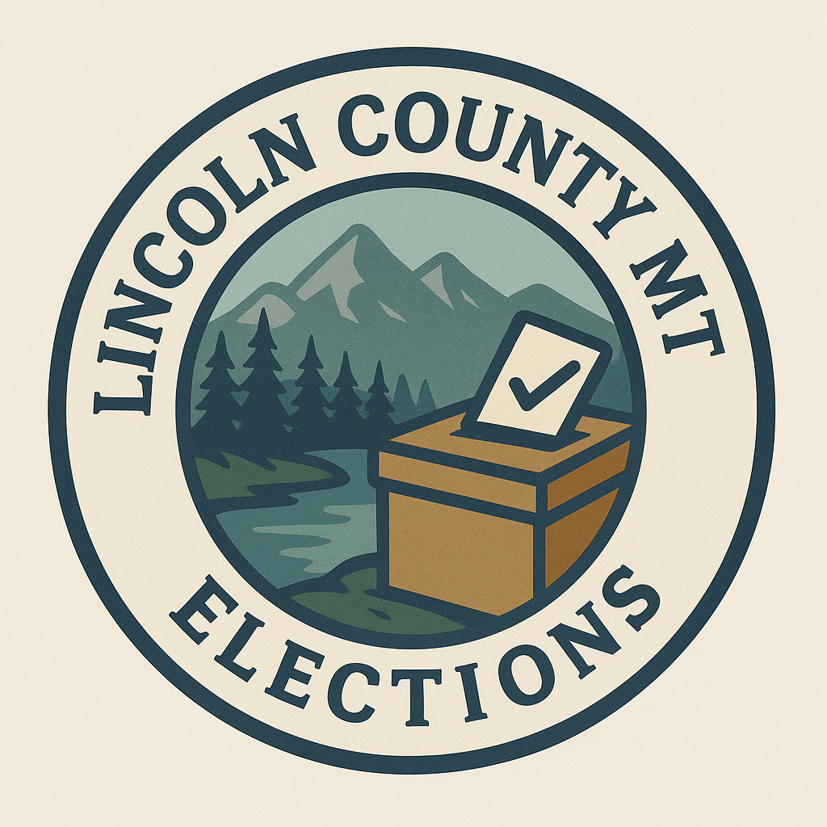
Lincoln County Voter Cancellation Request

Full Name:____________________________________________________________
Last Name First Name Middle initial

Date of Birth:________________

Residential Address:_______________________________________________________

City/State/Zip:____________________________________________

Reason for removal:__________________________________________________

13-2-402(1) MCA I hereby request that my voter’s registration in Lincoln County Montana be cancelled.

Signature:__________________________________________________

Date:_____________________

